**Automatic Irrigation System Based On Soil Texture With Farm Security**

Submitted in partial fulfillment of the requirements

of the degree of

Bachelor of Engineering in Computer science

By

Rutvik Kolhe (Roll No.14102B0046)

Nachiket Parchure (Roll No.14102B0066)

Darshan Mayekar (Roll No.14102B0045)

Under the Guidance of

Prof. Amit Nerurkar

Department of Computer Engineering

Vidyalankar Institute of Technology

Wadala(E), Mumbai-400437



University of Mumbai

2017-18

**CERTIFICATE OF APPROVAL**

This is to certify that the project entitled

**“Automatic Irrigation System Based On Soil Texture**

**With Farm Security”**

is a bonafide work of

**Rutvik Kolhe (Roll No.14102B0046)**

**Nachiket Parchure (Roll No.14102B0066)**

**Darshan Mayekar (Roll No.14102B0045)**

submitted to the University of Mumbai in partial fulfillment of the requirement

for the award of the degree of

**Undergraduate** in **“Computer engineering”**.

Guide Head of department Principal

Prof. Amit Nerurkar Prof. Arun Chavan Dr. S. A. Patekar

Project Report Approval for B. E.

This project report entitled

**Automatic Irrigation System Based On Soil Texture**

**With Farm Security**

By

**Rutvik Kolhe (Roll No.14102B0046)**

**Nachiket Parchure (Roll No.14102B0066)**

**Darshan Mayekar (Roll No.14102B0045)**

is approved for the degree of ***Bachelor of Engineering in Computer engineering.***

Examiners

1.---------------------------------------------

2.---------------------------------------------

Date:

Place:

**Declaration**

We declare that this written submission represents my ideas in my own words and where others' ideas or words have been included, I have adequately cited and referenced the original sources. I also declare that I have adhered to all principles of academic honesty and integrity and have not misrepresented or fabricated or falsified any idea/data/fact/source in my submission. I understand that any violation of the above will be cause for disciplinary action by the Institute and can also evoke penal action from the sources which have thus not been properly cited or from whom proper permission has not been taken when needed.

Name of Student Roll No. Signature

* **Rutvik Kolhe (Roll No.14102B0046)**
* **Nachiket Parchure (Roll No.14102B0066)**
* **Darshan Mayekar (Roll No.14102B0045)**

Date:

**Acknowledgement**

At the very outset of the project synopsis, we would like to extend our sincere and heartfelt thanks to all those who have helped the three of us with the endeavor. Without their active guidance, cooperation and encouragement we would not have made headway in this project. We are indebted to Prof. Amit Nerurkar for his conscientious guidance, insights, inputs and encouragement in helping us to complete this project.

We would like to extend our gratitude to Vidyalankar Institute of Technology and the department of computer engineering for providing us with the opportunity and means to complete our task.

Thanking you,

Rutvik Kolhe

Nachiket Parchure

Darshan Mayekar

**Abstract**

The increasing rate of world population demands for rapid improvement in food production technology. The agricultural sector has a major impact on the world economy, issues regarding which need to be solved by providing innovative solutions. The water scarcity due to the changing weather conditions and the lowering levels of underground water has given us a reason to use our water resource beneficially. About 30-35% of the crop yield is destroyed due to stray/wild animals. These issues can be solved by implementing the modern techniques into the traditional approach of farming. We propose an automatic irrigation system by analyzing the type of soil based on its water retention capacity. This approach would hoard the excessive water lost due to seepage into the lower layers of the soil. Contrarily, it would also eliminate the possibility of providing less water to the crops. In addition to that, we aim to provide farm security to protect against intruders and thieves, thereby protecting the yield. Our motive behind the project is to curb the extensive use of water for irrigation without any human intervention and send alerts for unusual activities in the farm to the user. Hence by implementing this method, we are able to save water which can be used for supplementary activities in the farm. The human effort required is reduced at an extensive level by implementing the automatic system.

**Table of Contents**

|  |  |  |
| --- | --- | --- |
| Sr No. | Content | Page No. |
| 1 | Introduction   * 1. Problem statement   2. Aim and objective   3. Literature survey | 1 |
| 2 | Analysis  2.1 Process model  2.2 Feasibility study  2.3 Cost analysis | 4 |
| 3 | Design  3.1 UML diagrams  3.2 Methodology | 8 |
| 4 | Implementation  4.1 Proposed system  4.2 User diagram | 14 |
| 5 | Working  5.1 System overview  5.2 Checking the soil type  5.3 Security module  5.4 Device used | 18 |
| 6 | Conclusion | 33 |
| 7 | Reference | 35 |

**INTRODUCTION**

**INTRODUCTION**

Agriculture plays a vital role to strengthen the world economy. Irrigation is the backbone of agriculture which requires significant measure of human effort among all other agricultural practices. The amount of water required differs with respect to the type of crop, type of soil, growth phase of the crop and climatic conditions. Very less or too much watering can damage the crop, hence it is essential to provide the exact amount of water required by the crop. Owing to the current climatic change around the world, the underground water level is decreasing which acts as a major threat to the natural water source. We developed a method to save water required for agriculture by identifying the texture of the soil. Soil can be classified based on its texture into- Sandy, Sandy Loam, Clayey Loam, Clay. The different textures can be identified based on their water holding capacity. Identification of the soil texture can help us save water in the following way, for example- If the water requirement of the crop is 100mm and if the water holding capacity of the soil is 50%, then in order to provide exact 100mm, we need to supply 200mm of water. This approach would prevent excessive water to be wasted by seepage into the lower layers of the soil. Contrarily, it will also prevent the scenario of reduced amount water supply thereby protecting the soil from extreme cases of draught or flooding.

It is essential to estimate the water requirement of each plot of land growing crops at any point of time in planning the supply of irrigation water to a field crop. This may be done by studying the interaction between a crop and the prevalent climate and the water requirement. The demand would, naturally be also dependant on the type and stage of growth. Plant roots extract water from the soil. Most of this water doesn’t remain in the plant but escapes to the atmosphere as vapour through the plants leaves and stems, a process which is called transpiration and occurs mostly during daytime. The water on the soil surface as well as the water attaching to the leaves and stem of a plant during a rainfall also is lost to the atmosphere by evaporation. Hence, the water need of a crop consists of transpiration and evaporation, together called evapotranspiration. Crop water requirements are defined here as "the depth of water needed to meet the water loss through evapotranspiration of a disease-free crop, growing in large fields under non-restricting soil conditions including soil water and fertility and achieving full production potential under the given growing environment.

* 1. **Problem Statement:**

Water is an important commodity in everyday life. Can we automatically water the plants when we on a vacation or do we have to bother our neighbors? Sometimes the neighbors do too much of watering and the plants end up dying anyway. They do not sense the soil moisture and the ambient temperature to know if the soil actually needs watering or not. Can we know if the soil actually needs to be watered? Irregular watering leads to mineral loss in the soil and might end up rotting the plants. So, the answer is Yes. In the existing concept, the water flow is turned on without analyzing external factors such as soil type thereby causing water wastage and a potential danger to the health of the plant helps in identifying the moisture content of the plants but it fails to measure the soil condition and provide a dynamic supply of water It fails to identify the suitability of the crop with respect to the soil, thereby limiting the productivity of the yield. The existing system helps to conserve water but does not provide any farmland security

* 1. **Aims and Objectives:**

Water is extensively used in the process of farming; hence we must strive to conserve it in every way possible.

**Primary Target:** Identify the soil type and suggest suitable crop and irrigate the field automatically when it is dry without any human intervention. This is done using a moisture sensor. A conductive sensor is placed into the soil which senses the moisture level of the soil and sends feedback to the microcontroller if the soil is dry which eventually activates the relay and the pump to irrigate the soil.

**Secondary target:** To detect any suspicious activity on the farm and if so an alert would be

sent to the farmer on his cellphone. Additionally, an alarm would ring in the farm along with flashlights to frighten the wild animal or intruder.

* 1. **Literature surveyed:**

By studying the existing system of the current smart irrigation systems, we were able to find out the short comings of the system. Also, after referring various papers we were able to summarize the existing system. The papers referred are as follows:

**Intelligent Automatic Plant Irrigation System**

Here, the concept is implemented using Arduino and the controlling of the motor is realized by using an Android application.

**Soil Parameters Monitoring with Automatic Irrigation System**

This includes measurement of only the soil moisture on the field thereby controlling the amount of water supplied

**Intelligent Automatic Plant Irrigation System**

This proposed technique is designed to operate a water pump automatically based on the soil moisture sensor detection of sufficient water to the plant or in fields and also temperature sensor-based fan speed control.

**Smart Farm using Wireless Sensor Network**

In farming Temperature, Humidity are the most essential parameters. The growth of crops is mainly depending on these three parameters. Currently farmers don't have any system which will show real-time levels of these parameters. Thus, helping farmers to take measures accordingly

**Smart Farm: Extending To Farm Level**

This project has attempted to introduce an efficient smart farm system. It has incorporated automation into various aspects of the farm. A new design for animal enclosures is put forward to improve the living conditions of livestock, as well as reduce manual labor. It includes an automated light, temperature, humidity and sprinkler system.

**ANALYSIS**

* 1. **Process Model**

For implementing our project, we are going to use Incremental model. Since the main feature of Incremental model is that it provides working model which becomes convenient in these ever-changing additional functionalities.

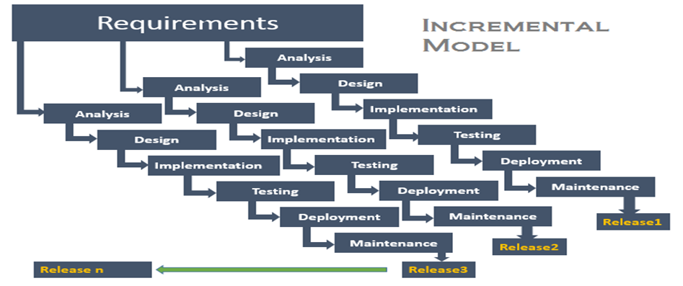

**Fig 2.1 Process Model (Incremental Model)**

The incremental build model is a method of software development where the product is designed, implemented and tested incrementally (a little more is added each time) until the product is finished. It involves both development and maintenance. The product is defined as finished when it satisfies all of its requirements. This model combines the elements of the waterfall model with the iterative philosophy of prototyping. The product is decomposed into a number of components, each of which is designed and built separately (termed as builds). Each component is delivered to the client when it is complete. This allows partial utilization of the product and avoids a long development time. It also avoids a large initial capital outlay and subsequent long waiting period. This model of development also helps ease the traumatic effect of introducing a completely new system all at once. There are, however, several problems with this model.

**Advantages-:**

1. After each iteration, regression testing should be conducted. During this testing, faulty elements of the software can be quickly identified because few changes are made within any single iteration.
2. It is generally easier to test and debug than other methods of software development because relatively smaller changes are made during each iteration. This allows for more targeted and rigorous testing of each element within the overall product.
   1. **Feasibility Study**

**Technical feasibility**: The project group members are equipped with knowledge and expertise on various technical topics to be implemented during the course of the project development. For guidance and professional expertise, the project guide is more than capable of providing precise and supreme solutions to unforeseeable problems during the course of the project development.

**Economic feasibility**: Though, the initial investment in the project are considerably high, but the project shall gain stability over its life resulting in substantial profits in long run.

**Legal feasibility**: After study of basic copyrights and law, the proposed system does not conflict with legal requirements, protection regulations and the proposed venture is acceptable in accordance to the laws as we aren’t violating any.

**Operational feasibility**: The proposed project is an improvement over an existing system. The timeline is suitable for the implementation and development of the project. The proposed system is sustainable and reliable.

**Financial feasibility**: The requirement of infrastructure will depend upon the size of the project. Thus investment in project will directly vary with the size of the project. Hence financial constrains if any should be considered while deciding the financial feasibility.

**Resource feasibility**: There is sufficient time available to build the new system, it can be built, and it does not interfere with normal business operations, type and amount of resources required, dependencies, and developmental procedures.

**2.3 COST ANALYSIS:**

**Hardware requirement:**

* Sensors: Proximity sensor (ASM18), Temperature sensor (LM35),

Humidity sensor (HS220), PIR sensor (REES52)

* Arduino Uno R3, ATmega328P Microcontroller
* SIM900A GSM Module
* Submersible water pump (3-6 V)
* Drip irrigation kit
* LED Lights
* Speaker
* Wires
* Resistors
* SIM card

**Software requirement:**

* Arduino IDE
* Operating System: Windows/Mac OS X/ Linux

Prices:

* Arduino Uno- Rs.500
* GSM Module- Rs. 600
* Sensors- Rs. 800
* Drip irrigation kit- Rs500
* Water pump – Rs 250

**Total cost**- Rs. 2500

**DESIGN**

**3.1 UML Diagrams:**

Here, we present how our application will be structured, what functions and modules it has and how we will implement efficient data transfer between devices. First we will look at the structure of our application with the help of UML diagrams like Use case diagram, state diagram and Communication diagrams

* 1. **Use Case Diagram:**

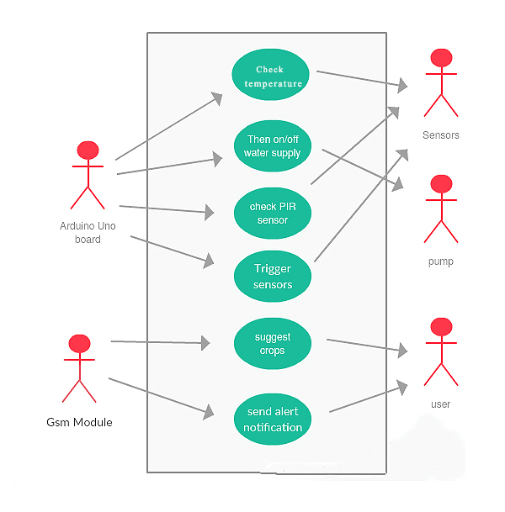

**Fig 3.1 Use Case Diagram**

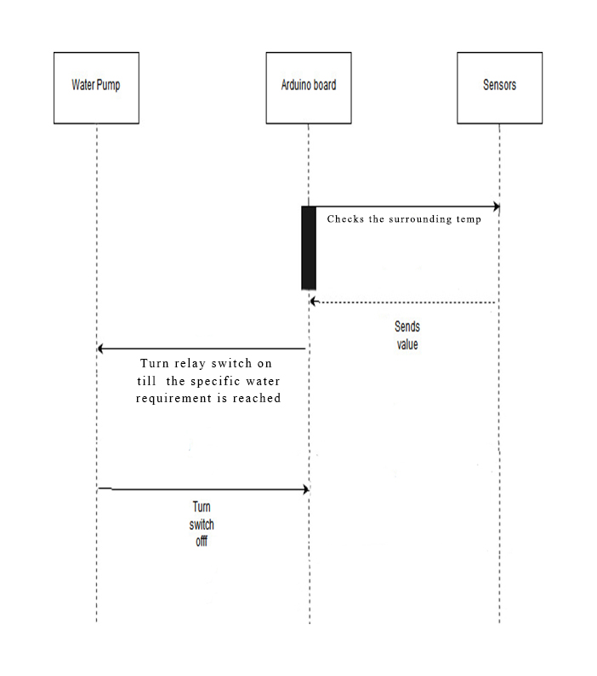

**Fig. 3.1.2 Sequence Diagram**

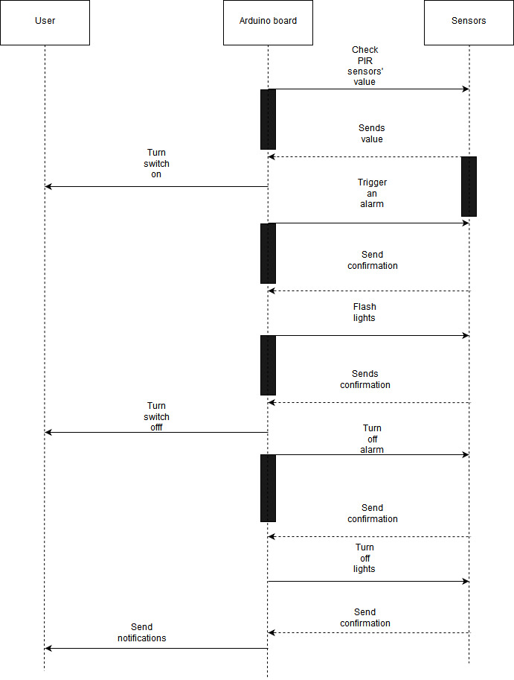

**Fig. 3.1.3 Sequence Diagram**

**3.2 METHODOLOGY**

An Arduino Uno microcontroller is used to which various sensors are attached. Firstly, the type of soil is identified by following a one-time analysis of the soil. The sample of the soil is taken and the moisture content of the soil is checked using the moisture sensor. Now, add 100ml of water and wait for 10 minutes. The water will be absorbed by the in the meantime and it will seep through the soil below. Now check the moisture level of the soil again. After comparing it with the previous value, we can conclude the water retention capacity of the soil. The water retention capacity of the soil is measured using a given standard formula. Now, we compare the value of the water retention of that particular sample to the values of standard types of soils. The types of soils include- Sandy soil, Loamy soil and Clayey soil. The type of soil can thus be concluded from the given process.

Now as we know the type of soil, we can provide suitable suggestions to the user by referring to the database containing the list of crops suitable for growth in that particular soil type and the region of the farm. This will enable the user to use all the resources in an optimum manner and amplify the profits. The suggestions of the crops will be sent to the user, using a SIM900A GSM module which is appended to the Arduino Uno. All the communication from the Arduino to the user will happen through this network only. The user will have an android application installed on the smartphone which will display the list of crops.

Water retention capacity of the soil plays an important role while determining the amount of eater to be supplied to the crop. Along with that, the weather predictions are also monitored using a weather api in the android app. Next, the amount of moisture in the soil is checked after repeated intervals to allow supply of water to the crop. If the moisture content of the crop drops below the decided threshold value, then the water supply is switched on. The threshold value is determined from the water retention capacity of the soil as well as the weather predictions for the day. It is also dependent on the amount of water needed by the particular crop. After the moisture content of the soil reaches a desired threshold value, the supply of the water is stopped by the Arduino. In this manner, a substantial amount of water is saved.

The protection of the farm from intruders is done by installing 4 PIR sensors in the middle of the field. PIR sensors only receive the infrared radiation emitted by the surrounding objects. The PIR sensor operates at an angle of 15 degrees, thereby providing an extensive support. Once an intruder enters the farm, the PIR sensor will sense a change in the value of infrared radiations and immediately an alarm would be triggered on. Subsequently, the lights would be switched on, flashing at a varied rate. Hence, the intruder would be alarmed and the farm would be protected. The sensors would be switched off after a certain time interval. A certain buffer period would be set after that particular time interval so that there is no definite pattern followed by the system.

**IMPLEMENTATION**

**4.1 Proposed System**

In this project there are different aspects to the system as follows:

**Identification of type of soil**: Soil is identified based on the experiment performed, after which the analysis is conducted. From this, the type of the soil is identified and the corresponding water holding capacity of the particular soil is noted which is further used to supply water.

**Automatic supply of water**: The automatic supply of water is done based on the calculations that include factor like temperature, crop coefficient from which the amount of water to be supplied each day is calculated. This is then further measured based on the type of soil and its water holding capacity. The amount of water finally to be supplied is calculated and the time for which it is supplied is derived from the supply speed of the motor which is used. In this case, it is 0.5 lit/min.

**Farm Security**: The farmland is protected using infrared sensors which would trigger the alarm and flashlights once an intrusion is detected. An sms would also be sent to the user using a GSM module directly to his personal cellphone. This would prove as an extra safety measure to protect the field against wild animals and human intruders.

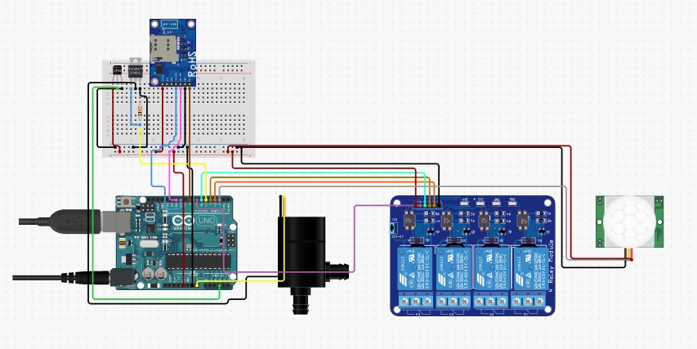

**Fig. 4.1 Circuit diagram**

**4.2 User Flow**

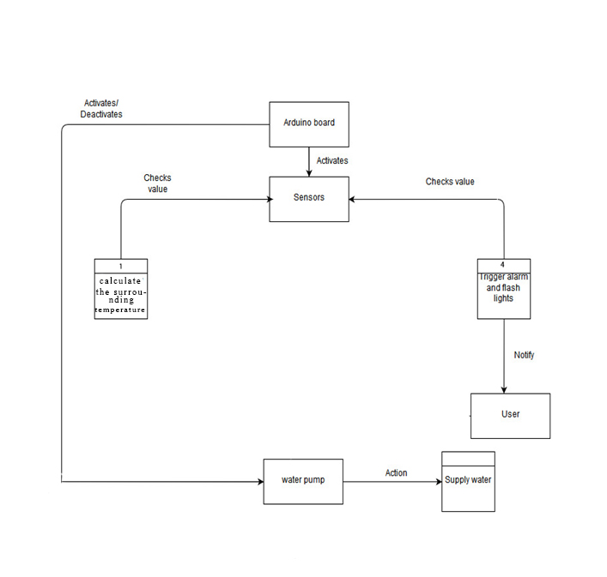

**Fig. 4.2 User Flow**

**Fig 4.3 User-Flow Diagram**

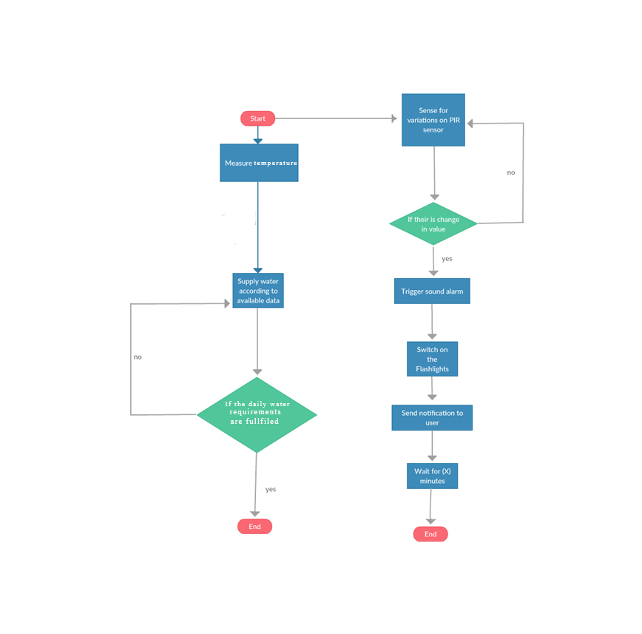

**WORKING**

**5.1 System overview**

Automatic plant irrigation system comprises five main components namely Arduino Uno, relay, alarm, PIR sensor and GSM module and to connect the parts or modules, we are using a bread board to simplify the connections. Whenever we go out of town for few days, we always used to worry about our plants as they need water on regular basis.

So, here we are making Automatic Plant Irrigation System using Arduino, which automatically provides water to your plants and keep you updated by sending message to your cell phone. In This Plant Watering System, whenever system switched On or off the pump, a message is sent to the user via GSM module, updating the status of water pump. This system is very useful in Farms, gardens, home etc. This system is completely automated and there is no need for any human intervention.

Required Components:

Arduino Uno, GSM Module, Connecting wires, 16x2 LCD (optional), Power supply 12v 1A, Relay 12v, Water cooler pump.

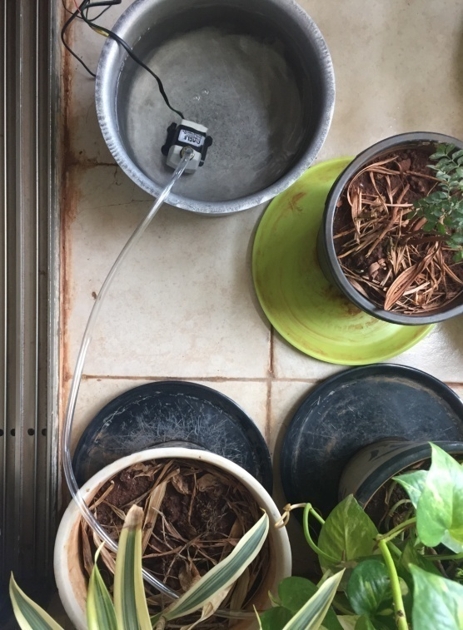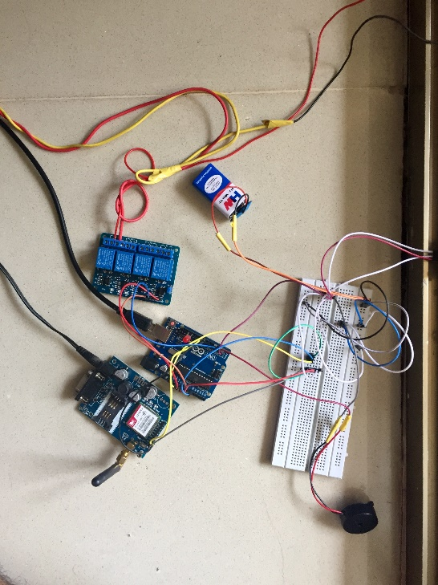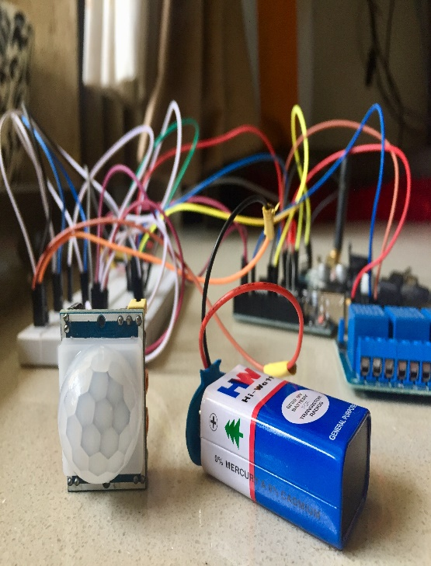

**Fig. 5.4.1 Circuit Connections**

**5.2 Checking the soil type:**

Good soil is the secret to healthy plants. This easy soil texture test will help you determine the percentages of sand, silt, and clay in your soil.

The ideal soil makeup consists of about: 40% sand, 40% silt, 20% clay.

**Materials Needed**

* Shovel
* Water
* Ruler
* Indelible marker
* Clear quart-sized jar (straight-sided jar best)
* Spoonful of powdered laundry or dish detergent (dispersant to aid in settling)

### **How to Test Soil Texture:**

### Remove the top 2” of the soil and clean the roots, twigs, rocks.

### Deposit 1/3rd soil sample in a jar.

### Add water and detergent to the jar and shake it well.

### To calculate the percentage, divide the depth of each layer of soil by the total soil depth in the jar, and multiply with 100.

### 

**Interpreting Soil Test Results**

Now that you have calculated the percentages of soil components, you have a general idea of your soil type and can choose plants that are well-suited to your native soil. If you’d like to get more scientific about it, consult the soil pyramid below to find the scientific classification of your soil based on the percentages of each layer.

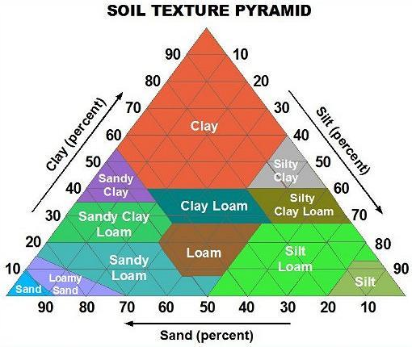

**Fig. 5.2.1 Soil Texture Pyramid**

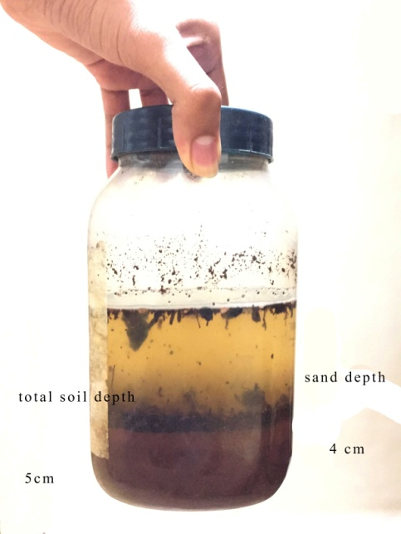

**Fig. 5.2.2 Soil Analysis**

* **Farm Soil:** (sandy loam) 70% sand, 20% silt, 10% clay
* **Yard Soil:** (sandy clay loam) 50% sand, 25% silt, 25% clay

Crop water requirement is the most important factor to be decided during the process of agriculture. To measure the crop water requirement for a particular crop per day, the ET of the crop is calculated as

“ETcrop = kc* ETo

Here, ETo is the reference crop evapotranspiration value which can be found using the Blaney Cridle method. The empirical formula to calculate the ETo is given as:

“ETo = p (0.46 * Tmean + 8)

Here, Tmean is the mean daily temperature which can be calculated by knowing the maximum temperature (Tmax) and minimum temperature(Tmin) using the formula:

“Tmean = (Tmax + Tmin)/2

Based on the latitude for that particular region, we can set the value of p accordingly for each month. The following table shows the different values of ‘p’:

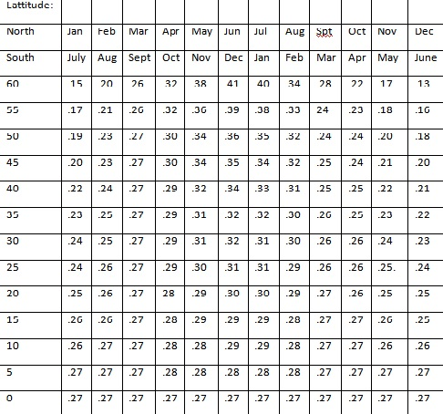

**Table 5.1: Values of p used to calculate amount of water required by the crop**

To account for the effect of the crop characteristics on crop water requirements, crop coefficients (kc) are presented to relate ETo to crop evapotranspiration (ETcrop). The values of crop coefficient are dependent on the growth phase of the crop. The value of kc changes throughout the growth period, hence for calculation purposes we use the average of all the kc values. The kc values of common crops are given as follows:

|  |  |
| --- | --- |
| **Crop Name** | **Values of kc** |
| Cotton | 0.82 |
| Maize | 0.82 |
| Millet | 0.79 |
| Sorghum | 0.78 |
| Grains (small) | 0.78 |
| Legumes | 0.79 |
| Groundnuts | 0.79 |

**Table 5.2: Values of crop coefficient (kc)**

## **Water Supply**

Using these values of ETo and kc, we can determine ET which gives us the water requirement on a daily basis as stated above. Since we know the values of daily water usage of the crop and the water holding capacity of the soil, we propose to use both to efficiently supply water to the crop using a water pump connected to a relay which is in turn connected to the Arduino Uno. ETcrop gives us the amount of water (in mm) to be supplied for a single day. To calculate the actual amount of water required (in liters), we use the following formula:

Amount of water required= ETcrop* 1000* Area of farm (in square meters)

Since we know the values of daily water usage of the crop and the water holding capacity of the soil. The amount of water supplied can be calculated by the formula:

Amount of water to be supplied = Amount of water required / Soil water holding capacity %

The total amount of water to be supplied can be distributed at particular intervals during the entire day to ensure uniform seepage of water to the crop.

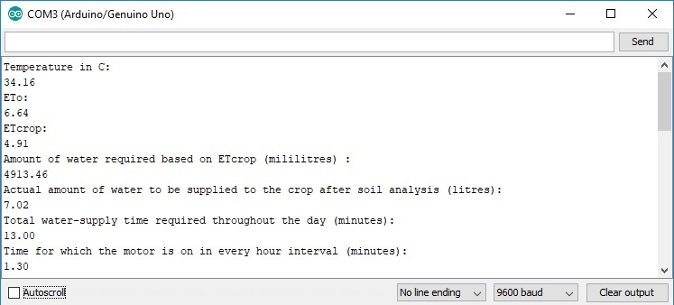

**Fig. 5.2.1 Screenshot of the output for Pump**

Description: The system calculates the Eto which is the general value that considers the evapotranspiration rate of the surroundings based on the temperature and latitude. It then calculates the value of Etcrop based on the crop coefficient o the particular crop. The Etcrop value gives us the amount of water to be supplied to the crop per day. Then, the amount of water to be supplied to the crop based on soil texture is calculated. The soil texture would differentiate different soils based on their water retention capacity and based on this capacity, extra water is supplied to the crop so that it retains the required amount of water. Now, based on the speed of the motor, the total supply time for which the motor should remain switched on is calculated. This time is divided into the fixed number of hour intervals. These hour intervals are decided by the user, so that the water can be supplied during this time.

**Fig. 5.2.2: Screenshot of the time elapsed between each water supply interval**

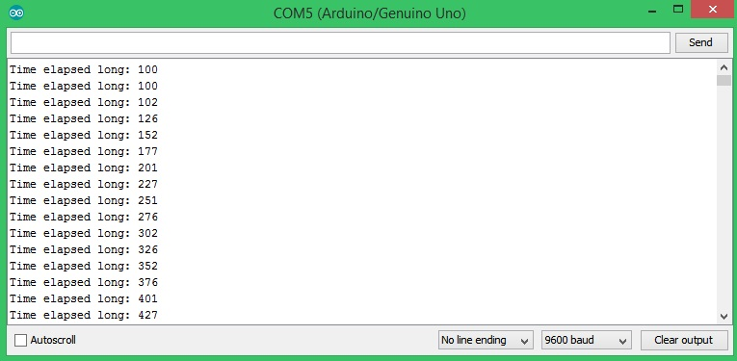

Description: This shows the time for which the system waits between two water intervals (1 hour)

**Fig. 5.2.3: Screenshot of the time elapsed for which the water supply is on starts**

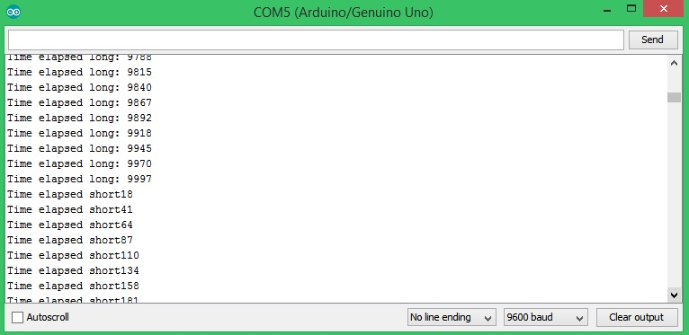

Description: This shows that the interval ends and then shows the time for which the water supply would be kept on.

**Fig. 5.2.4: Screenshot of the time elapsed for which the water supply ends**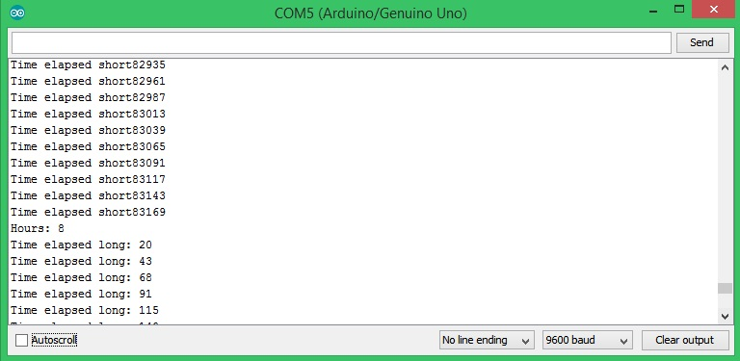

Description: This shows that the time for which the water supply is kept on ends and also displays the number of hours left in the time interval through the entire day.

**Fig. 5.2.5: Values of the PIR sensor**

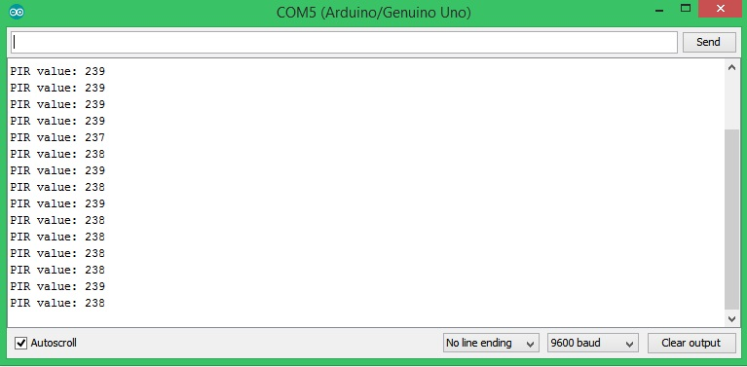

Description: This displays the values which are read by the passive infrared sensor

**Fig. 5.2.6: GSM Sim900A output**

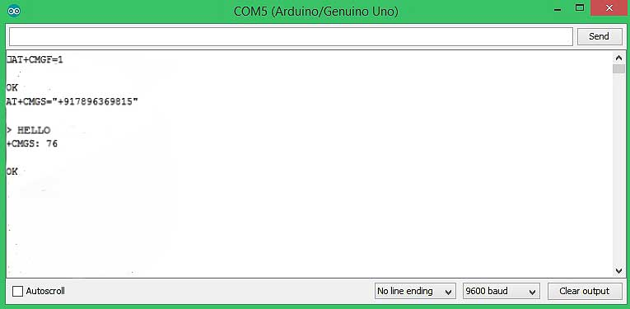

Description: This window shows the number to which the message is sent along with the message that is being sent to that particular user

**5.3 Security module:**

The protection of the farm from intruders is done by installing 4 PIR sensors in the middle of the field. PIR sensors only receive the infrared radiation emitted by the surrounding objects. The PIR sensor operates at an angle of 15 degrees, thereby providing an extensive support. Once an intruder enters the farm, the PIR sensor will sense a change in the value of infrared radiations and immediately an alarm would be triggered on. Subsequently, the lights would be switched on, flashing at a varied rate. Hence, the intruder would be alarmed and the farm would be protected. The sensors would be switched off after a certain time interval. A certain buffer period would be set after that particular time interval so that there is no definite pattern followed by the system.

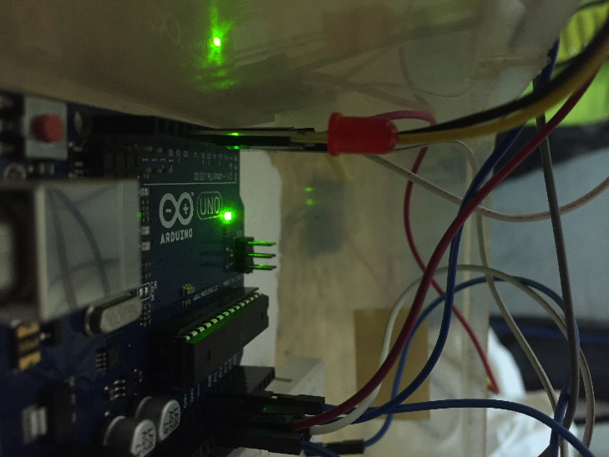 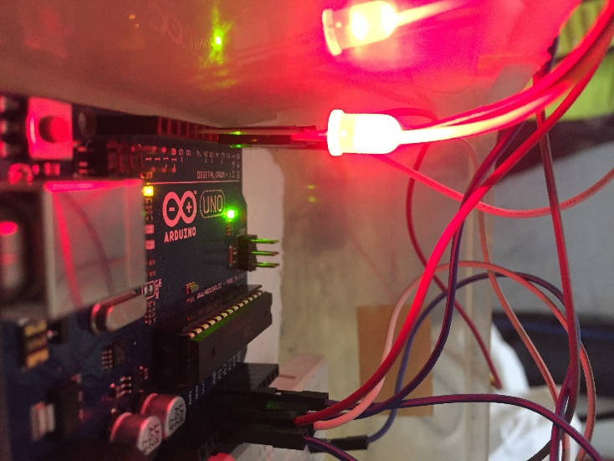

**Fig 5.3.1: LED gets automatically switched on whenever any motion is detected in the field**

**5.4 Devices**

**5.4.1 Arduino:**

The Arduino UNO is a widely used open-source microcontroller board based on the ATmega328P microcontroller and developed by Arduino. The board is equipped with sets of digital and analog input/output (I/O) pins that may be interfaced to various expansion boards (shields) and other circuits.  The board features 14 Digital pins and 6 Analog pins. It is programmable with the Arduino IDE (Integrated Development Environment) via a type B USB cable. It can be powered by a USB cable or by an external 9-volt battery, though it accepts voltages between 7 and 20 volts.

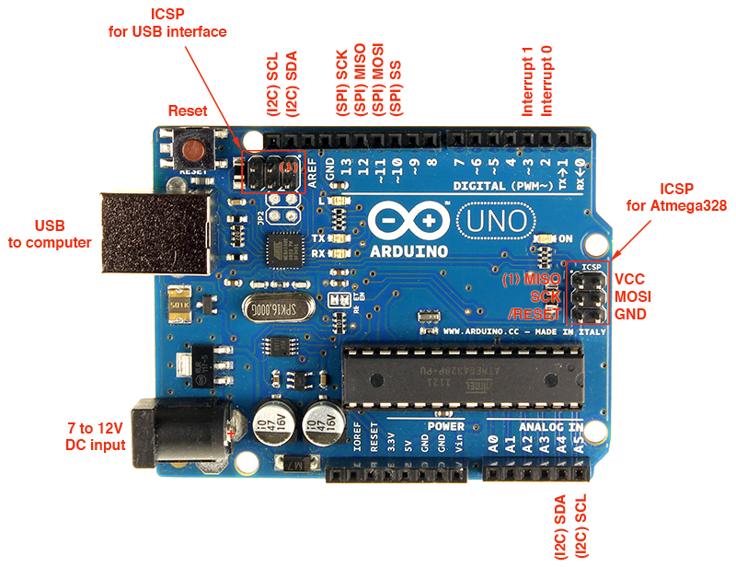

**Fig. 5.4.1 Pin Diagram Of Arduino Uno**

**5.4.2 GSM module:**

**GSM** is a standard developed by the European Telecommunications Standards Institute (ETSI) to describe the protocols for second-generation digital cellular networks used by mobile devices such as tablets, first deployed in Finland in December 1991. As of 2014, it has become the global standard for mobile communications – with 90% market share, operating in over 193 countries and territories.

2G networks developed as a replacement for first generation (1G) analog cellular networks, and the GSM standard originally described as a digital, circuit-switched network optimized for full duplex voice telephony. This expanded over time to include data communications, first by circuit-switched transport, then by packet data transport via GPRS (General Packet Radio Services) and EDGE (Enhanced Data rates for GSM Evolution, or EGPRS).

Subsequently, the 3GPP developed third-generation (3G) UMTS standards, followed by fourth-generation (4G) LTE Advanced standards, which do not form part of the ETSI GSM standard.

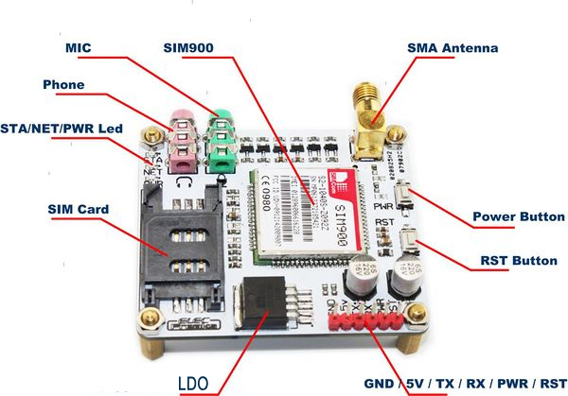

**Fig. 5.4.2: GSM SIM900**

**5.4.3 Relay switch**

A **relay** is an electrically operated switch. Many relays use an electromagnet to mechanically operate a switch, but other operating principles are also used, such as solid-state relays. Relays are used where it is necessary to control a circuit by a separate low-power signal, or where several circuits must be controlled by one signal. The first relays were used in long distance telegraph circuits as amplifiers: they repeated the signal coming in from one circuit and re-transmitted it on another circuit. Relays were used extensively in telephone exchanges and early computers to perform logical operations.

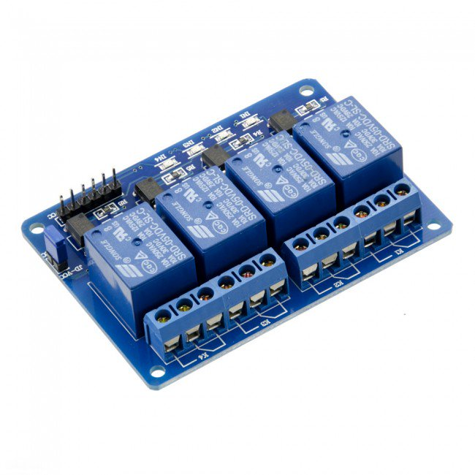

**Fig. 5.4.3: 4- Channel Relay Switch**

**5.4.4 PIR sensor**

A passive infrared sensor (PIR sensor) is an electronic sensor that measures infrared (IR) light radiating from objects in its field of view. They are most often used in PIR-based motion detectors. All objects with a temperature above absolute zero emit heat energy in the form of radiation. Usually this radiation isn't visible to the human eye because it radiates at infrared wavelengths, but it can be detected by electronic devices designed for such a purpose. The term *passive* in this instance refers to the fact that PIR devices do not generate or radiate energy for detection.

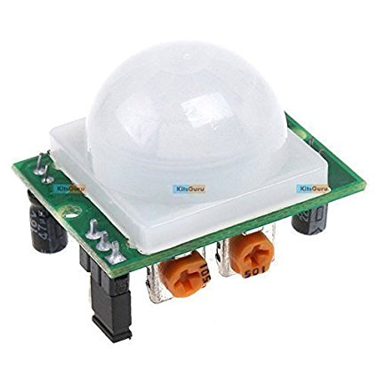

**Fig. 5.4.4: PIR Sensor**

**5.4.5 Alarm**

An alarm device or system of alarm devices gives an audible, visual or other form of alarm signal about a problem or condition. Alarm devices are often outfitted with a siren. Alarms have the capability of causing a fight-or-flight response in humans; a person under this mindset will panic and either flee the perceived danger or attempt to eliminate it, often ignoring rational thought in either case. A person in such a state can be characterized as "alarmed".

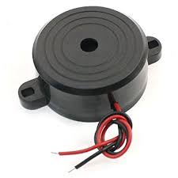

**Fig. 5.4.5: Buzzer**

**5.4.6 A submersible pump**

A submersible pump (or sub pump, electric submersible pump (ESP)) is a device which has a hermetically sealed motor close-coupled to the pump body. The whole assembly is submerged in the fluid to be pumped. The main advantage of this type of pump is that it prevents pump cavitation, a problem associated with a high elevation difference between pump and the fluid surface. Submersible pumps push fluid to the surface as opposed to jet pumps having to pull fluids. Submersibles are more efficient than jet pumps.

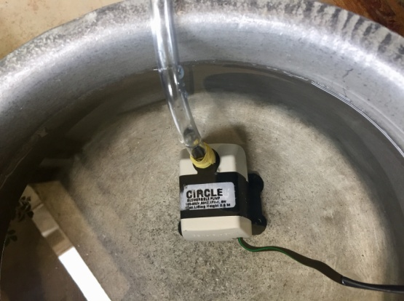

**Fig. 5.4.6: Submersible pump**

**CONCLUSION**

**Conclusion**

We have started with a simple idea of automating the plant irrigation system. Sufficient efforts are invested and good basic system is presented which is sufficient for a system implementation. In the paper, we have mainly focused on improving the existing plant irrigation system and farmland security from our proposed system. Even though, we have overcome some of the difficulties to the implementation; there would not be the obstacle for the initiation. Certainly, working on this project would improve overall efficiency of the system. But currently, we consider the future scope of the system.

Currently the system is proposed for irrigation and farmland security models but the same can be further extended to work with more sensors like, soil testing and more. also. It is easy to understand that the core part of the system i.e. Arduino and PIR sensors. This project is currently in its primary stage and only covers automation and security part. Further it can be extended to analyze the crop types and sensors to be more sensitive and accurate. We can even try to implement and improve the design of App by using more advanced methods there by reducing the human effort.

**REFERENCES**

**References**

1. “Design and Implementation of an Intelligent Security System for Farm Protection from Wild Animals”by Prof. Abhinav V. Deshpande (Nov 2016).
2. “Intelligent Control Based Fuzzy Logic for Automation of Greenhouse Irrigation System and Evaluation in Relation to Conventional Systems” byP. Javadi Kia, A. Tabatabaee Far, M. Omid, R. Alimardani and L. Naderloo Department of Agricultural Machinery Engineering, University of Tehran, Karaj, Iran(2009).
3. “Intelligent Automatic Plant Irrigation System”by Shaikh Gauher Darren (IJAICT)-(Nov 2016)
4. “Soil Parameters Monitoring with Automatic Irrigation System” by SonaliGainwar(IJSETR)(Nov 2015)
5. “Review paper based on automatic irrigation system based on rf module” by Ms. DeweshvreeRane PG Scholar - VLSI, Prof. P. R. Indurkar Professor, BDCE, Prof. D. M. Khatri Assistant Professor, BDCE, Sevagram, Sevagram, Wardha, India.(Jan 2015)
6. “Applications of Smartphone-Based Sensors in Agriculture”: A Systematic Review of Research SupornPongnumkul, PimwadeeChaovalit, and NavapornSurasvadi (July 2015)
7. “Design and Implementation of an Intelligent Security System for Farm Protection from Wild Animals” by Prof. Abhinav V. Deshpande (2013)
8. “Intelligent Automatic Plant Irrigation System“ by Shaikh GauharZareen, Khan SannaZarrin , Ansari Rabsha Ali, Prof. S. D. Pingle(Nov 2016)
9. “Automated Measurement of Soil Moisture for Improvement of Irrigation Scheduling in Nurseries”by Gerrit Hoogenboom and James B. Houser
10. “Smart Farm: Extending Automation To The Farm Level”by Drishti Kanjilal, Divyata Singh, Rakhi Reddy, Prof Jimmy Mathew(July 2014)